Title:
Project 1: Building and Configuring a Linux Environment
Student Name:
Pelumi Johnson
Course:
Introduction to Linux
Submission Date:
11/11/2025

1.1 Part 1: Set Up a Virtual Machine
- Download and Install Virtual Machine Software
1.2 Download Linux ISO and Create a New Virtual Machine
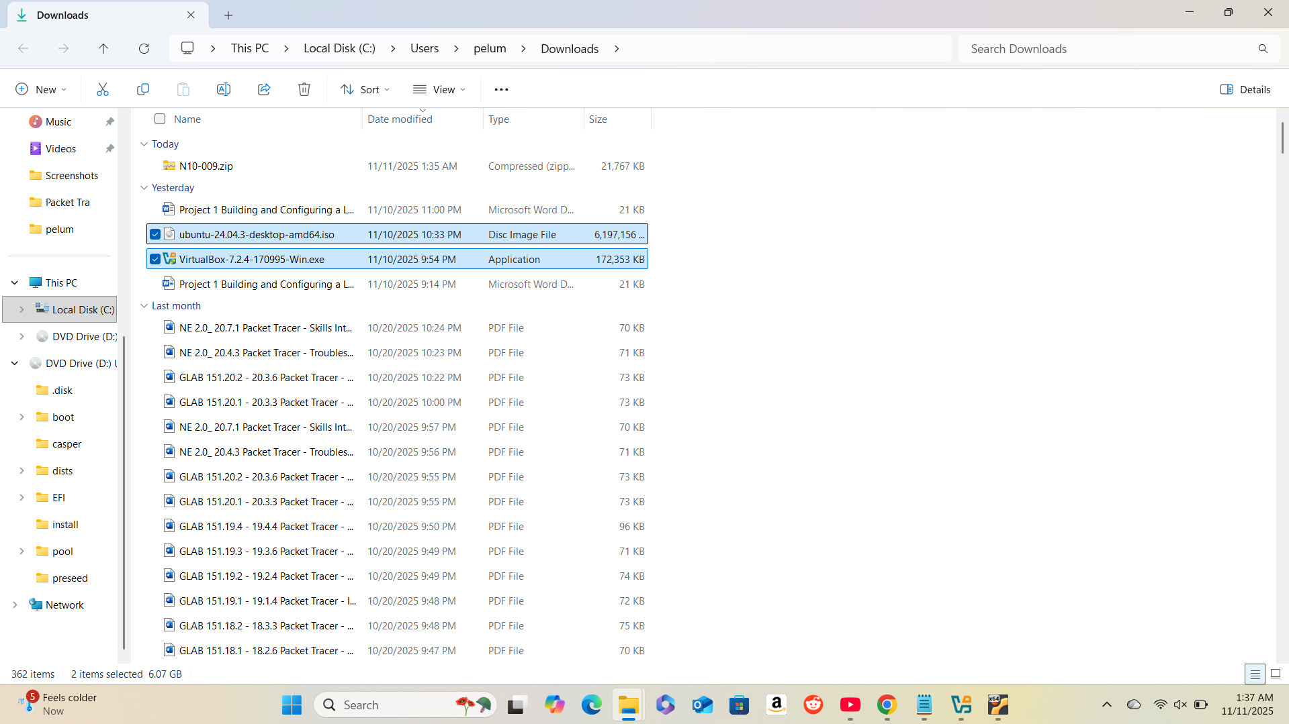

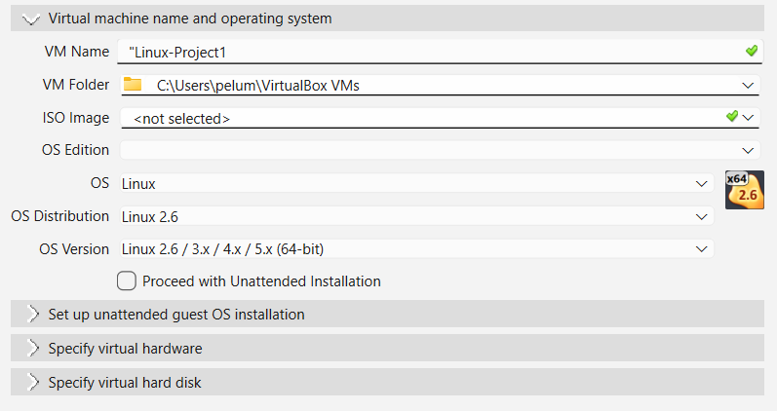

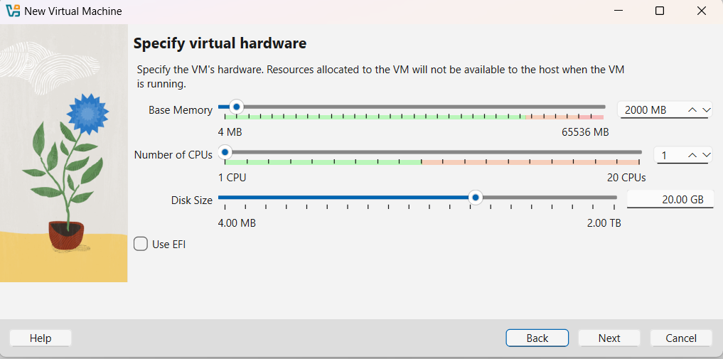

1.3 Install the Linux OS
Describe the installation process and any custom settings used.
I installed Ubuntu 24.04.3 LTS using Oracle VirtualBox. First, I created a new virtual machine, allocated 2 GB of RAM and 25 GB of virtual hard drive space, and attached the Ubuntu ISO file. I selected the interactive installation option, chose English as the language, and used the default installation type (Erase disk and install Ubuntu). I enabled third-party software installation, selected the default app set, and created a user account named “Pelumi Johnson.” After installation, I restarted the VM and verified successful setup and internet connectivity using the ping google.com command in the Linux terminal.

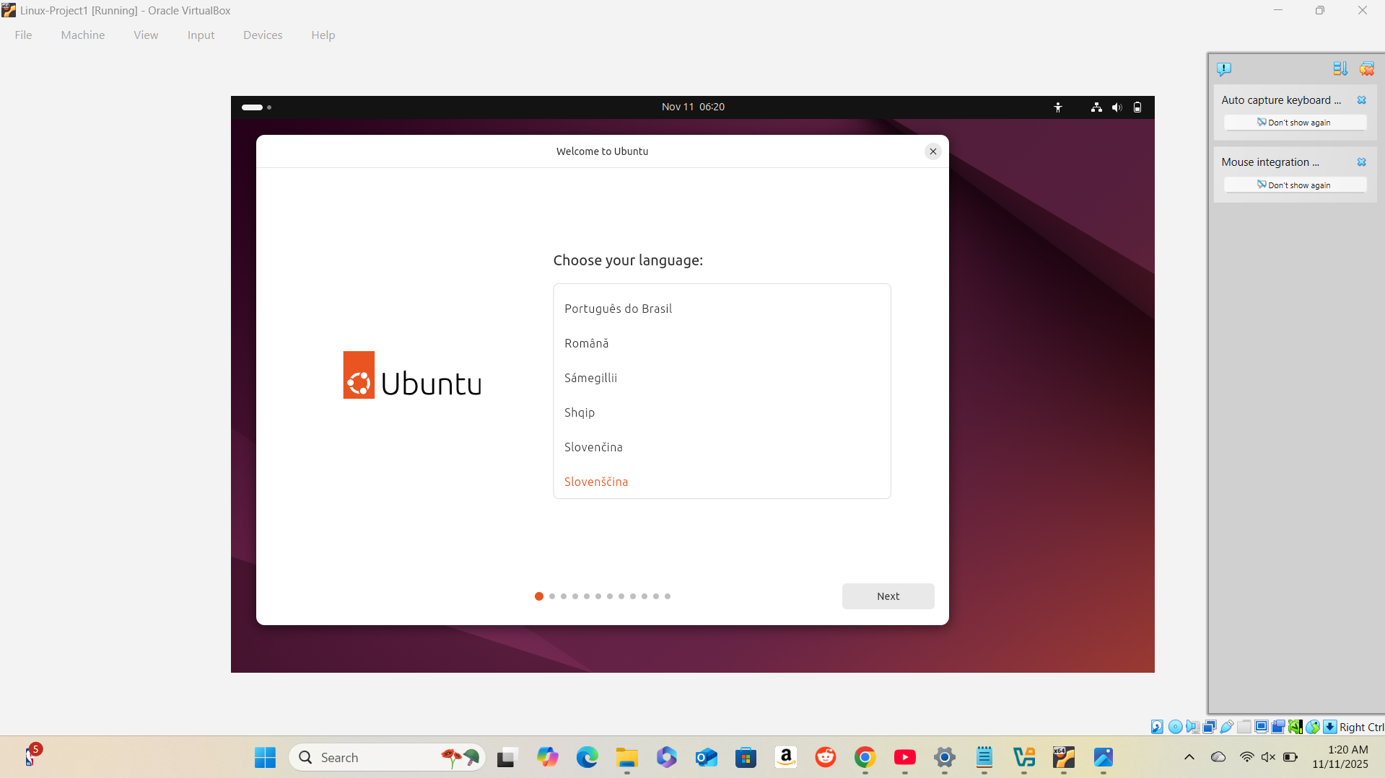

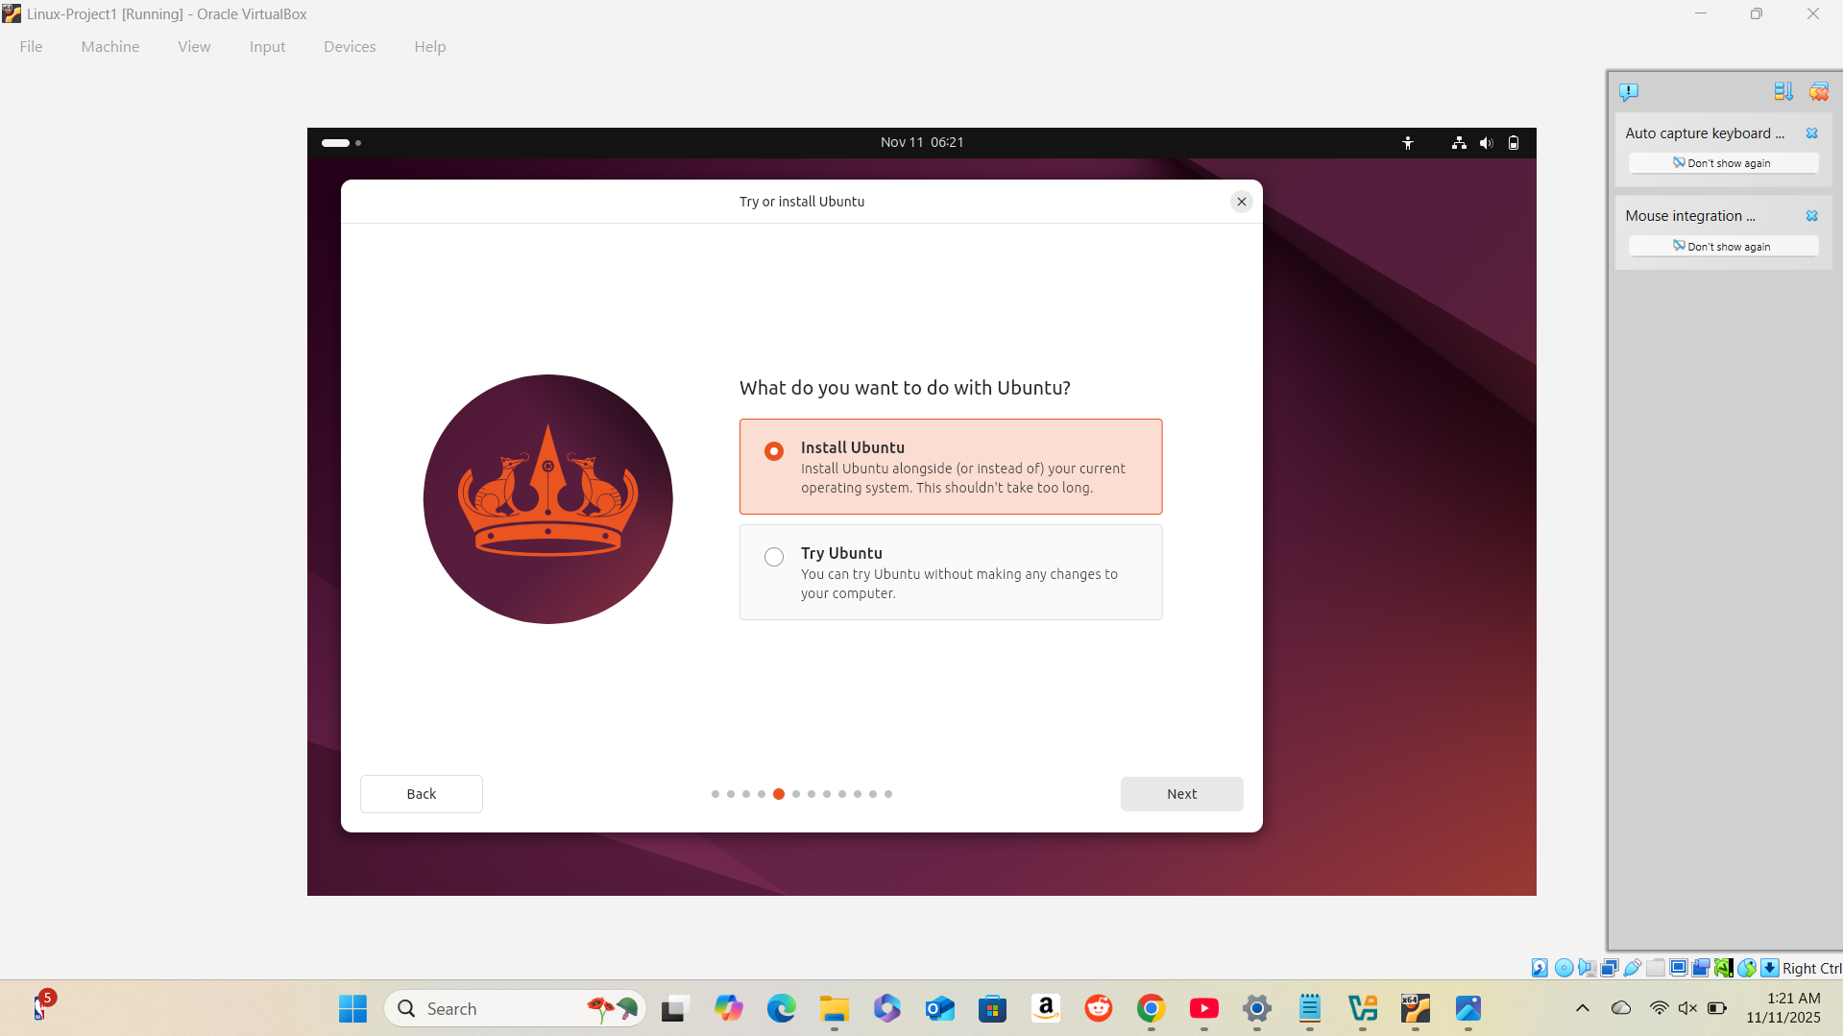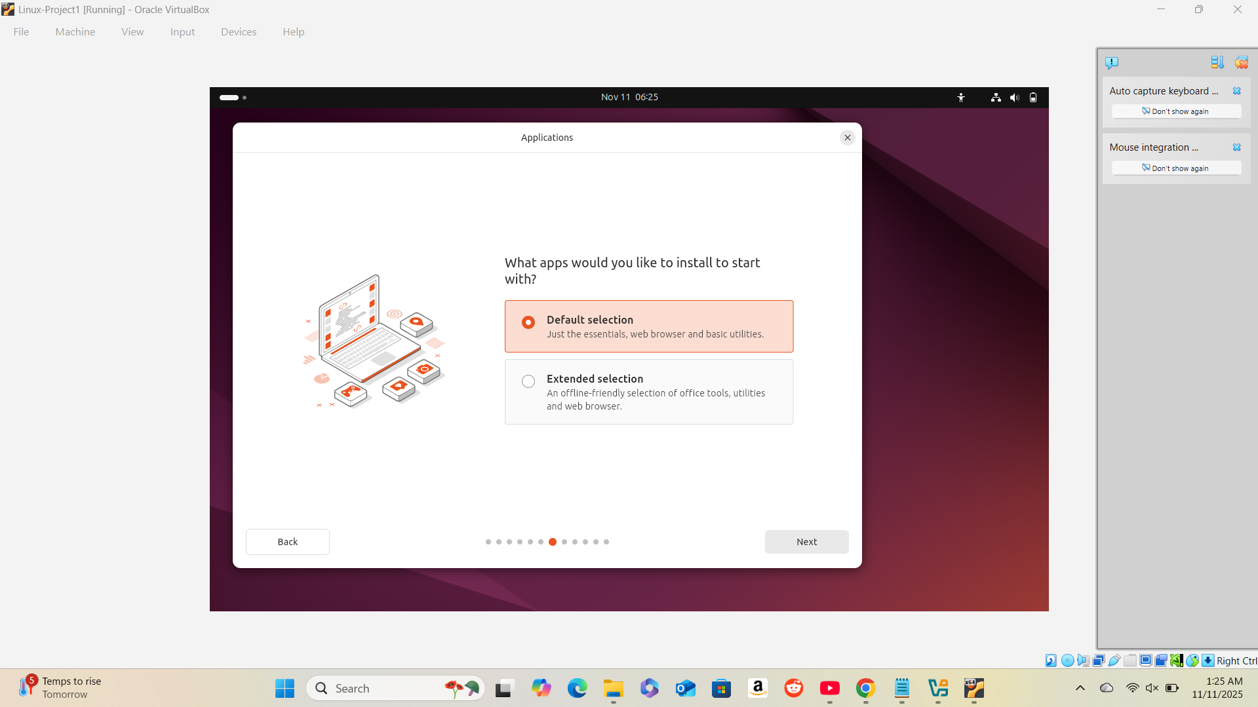

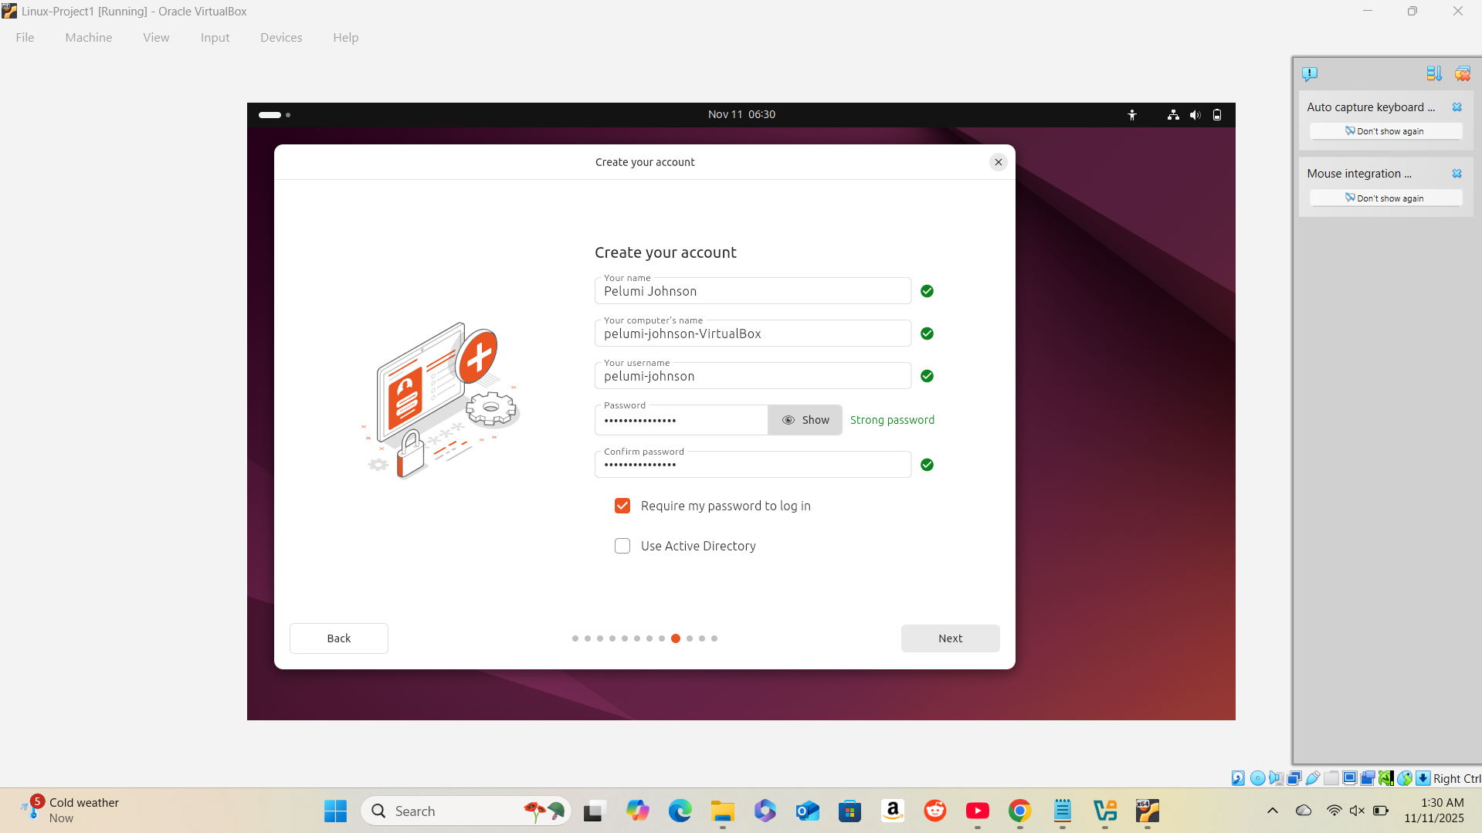

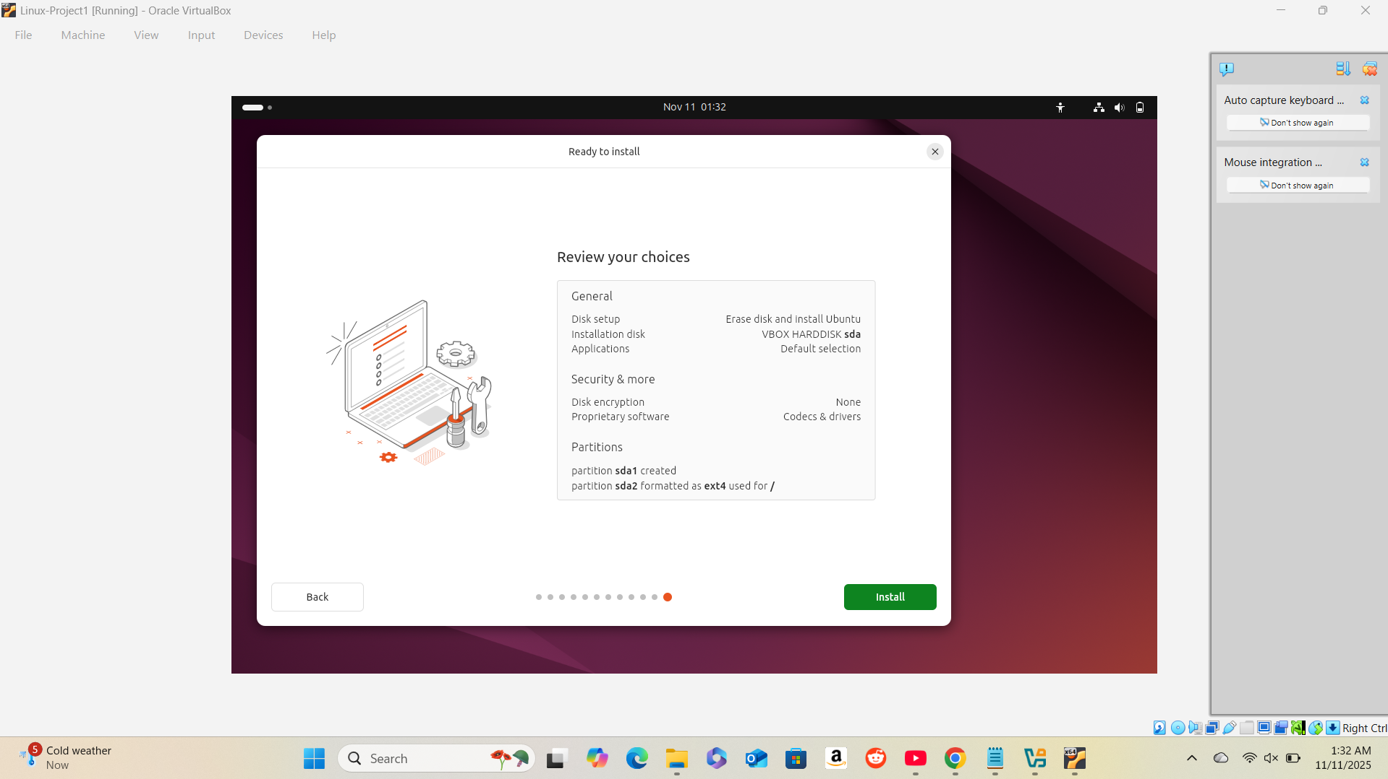

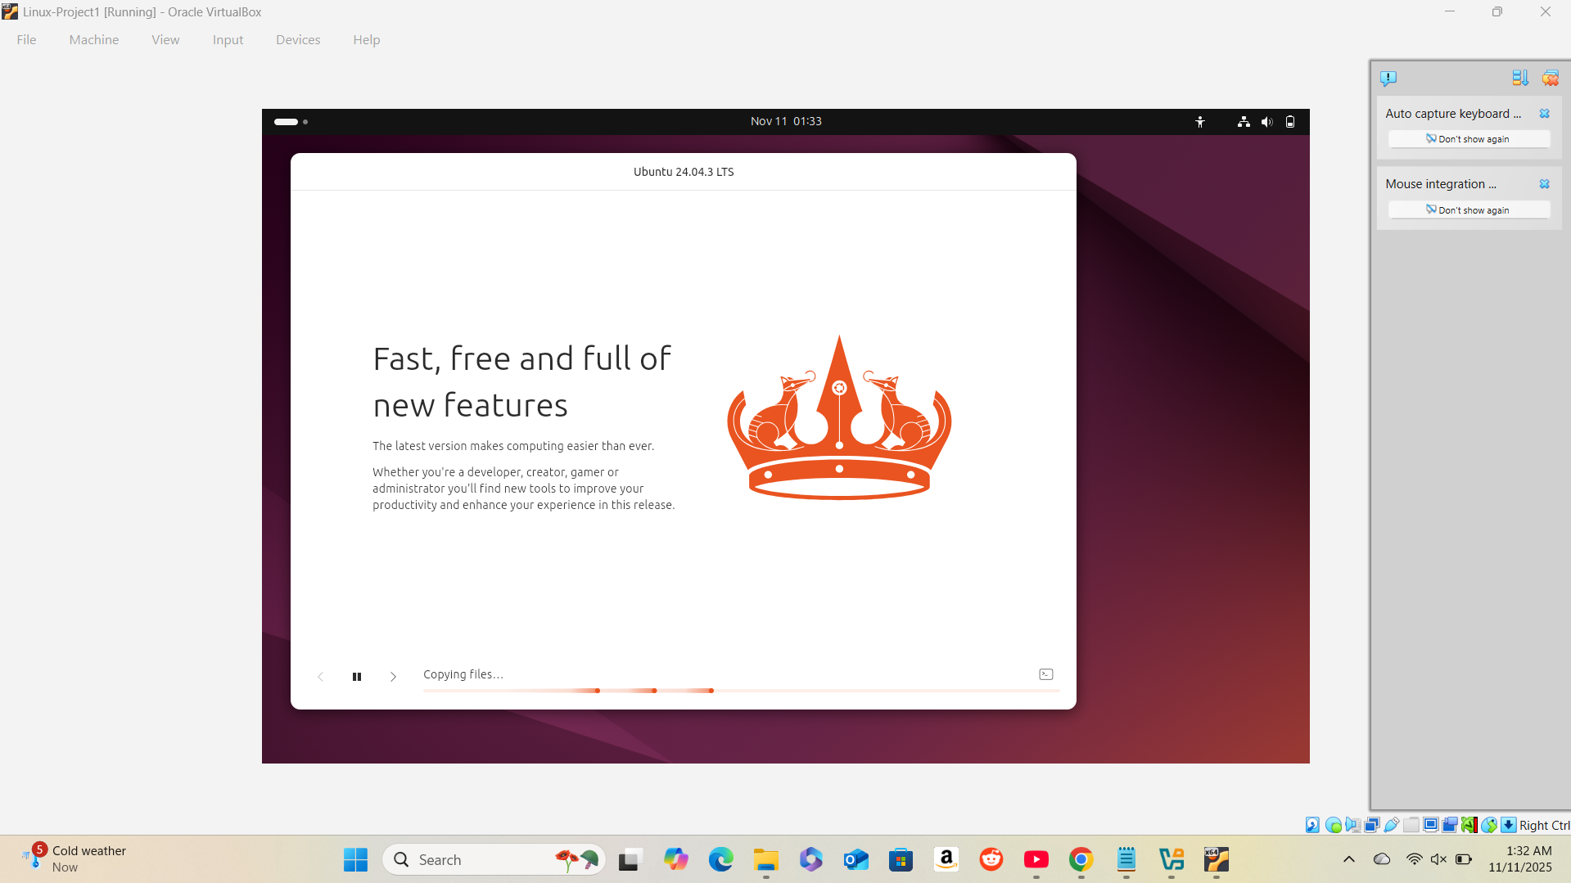

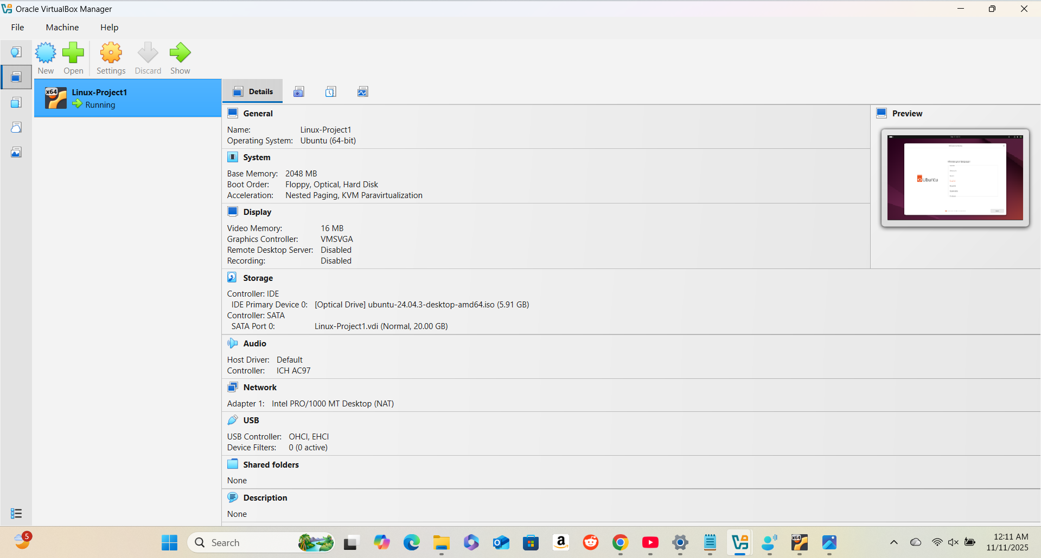
1.4 Verify Installation
- Record the command, its purpose, and the resulting output.
After installation, I booted into the Ubuntu Linux environment. To confirm that the operating system and network were functioning correctly, I opened the Terminal and used the command:
ping google.com
Purpose: The ping command tests internet connectivity by sending data packets to a website and measuring the response time.
Result: The terminal displayed a series of replies such as “64 bytes from google.com...” , confirming that the system was successfully connected to the internet and functioning properly.

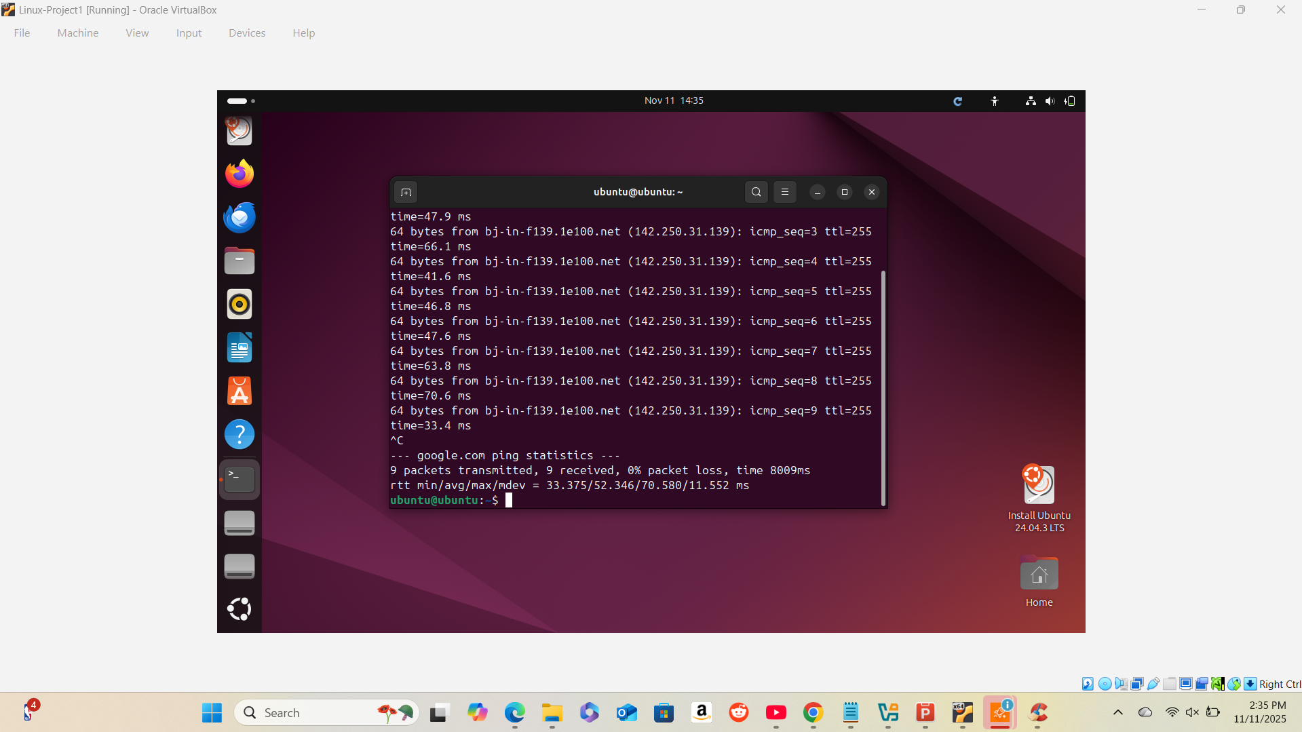

2. Part 2: File System Exploration
2.1 Navigating the File System
- Include a short explanation of what each command does and your observations.
- pwd – Prints the current working directory path.
- ls – Lists the files and folders in the current directory.
- cd – Changes from one directory to another.
Key directories explored:
- /home – Stores user files and personal folders.
- /var – Holds system logs and variable data.
- /etc – Contains system and software configuration files.
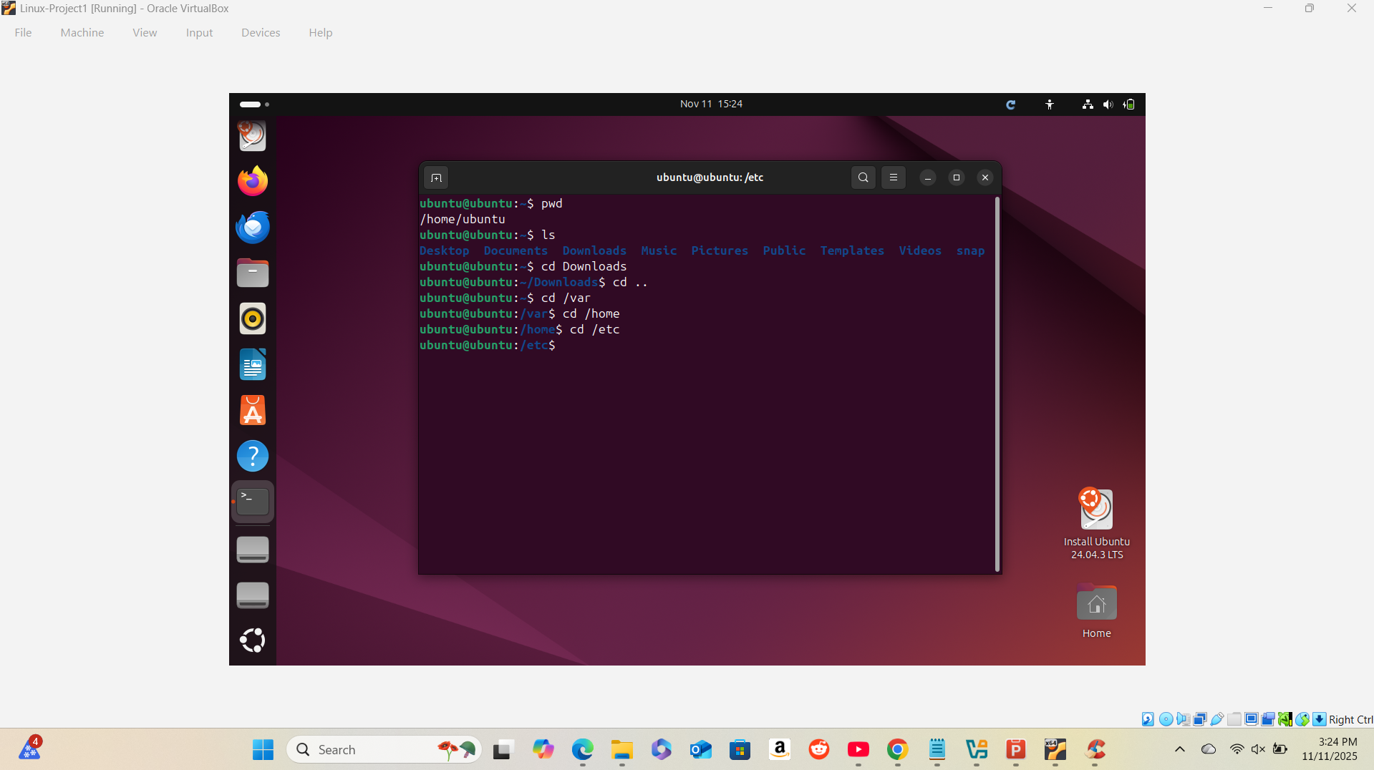
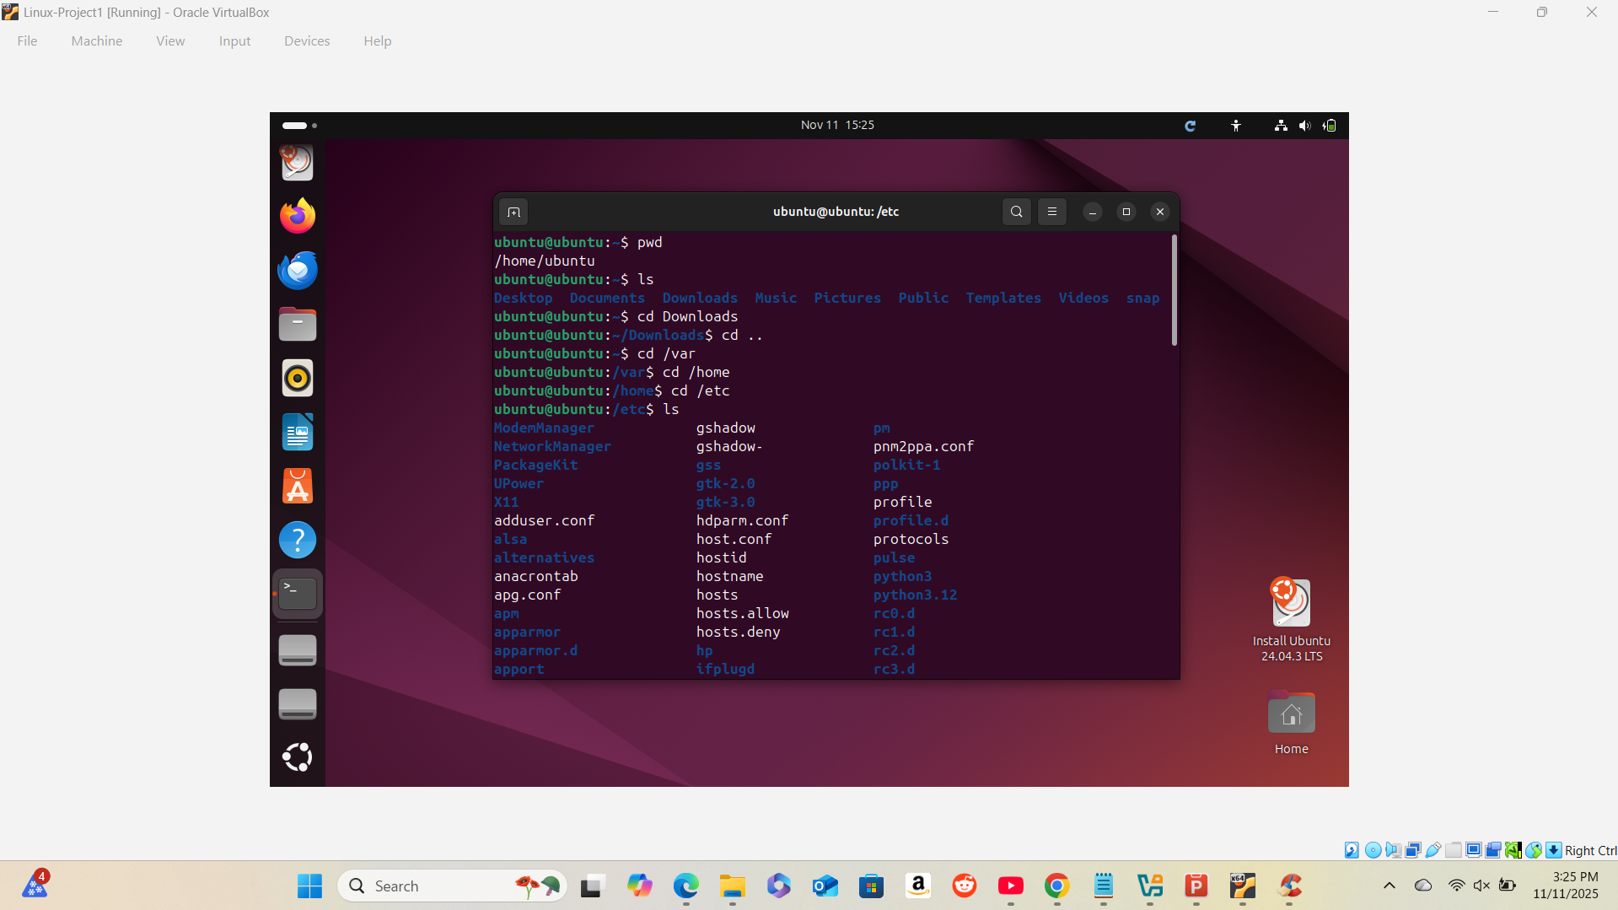

2.2 Create and Manipulate Files/Directories
- List each command with a brief description of its purpose.
mkdir project1_files – Creates a new directory named project1_files.
cd project1_files – Moves into the newly created directory.
touch file1.txt – Creates a new, empty text file called file1.txt.
mv file1.txt renamed_file.txt – Renames file1.txt to renamed_file.txt.
rm renamed_file.txt – Deletes the file renamed_file.txt.

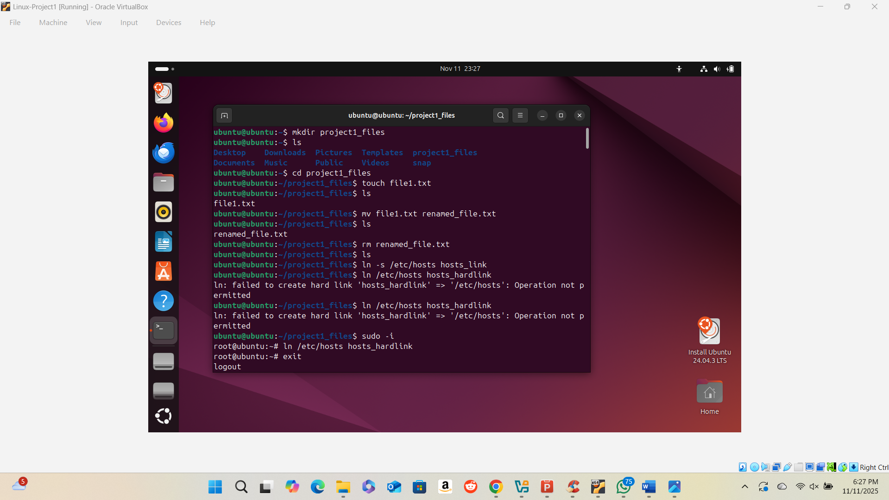

2.3 Create Links
- Describe the difference between symbolic and hard links and document the commands.
Hard Link: Directly links to a file’s data. It remains valid even if the original file is deleted.
Command: ln file1.txt file1_hardlink.txt
Symbolic Link: Acts as a shortcut to a file path. It breaks if the original file is deleted.
Command: ln -s file1.txt file1_symlink.txt

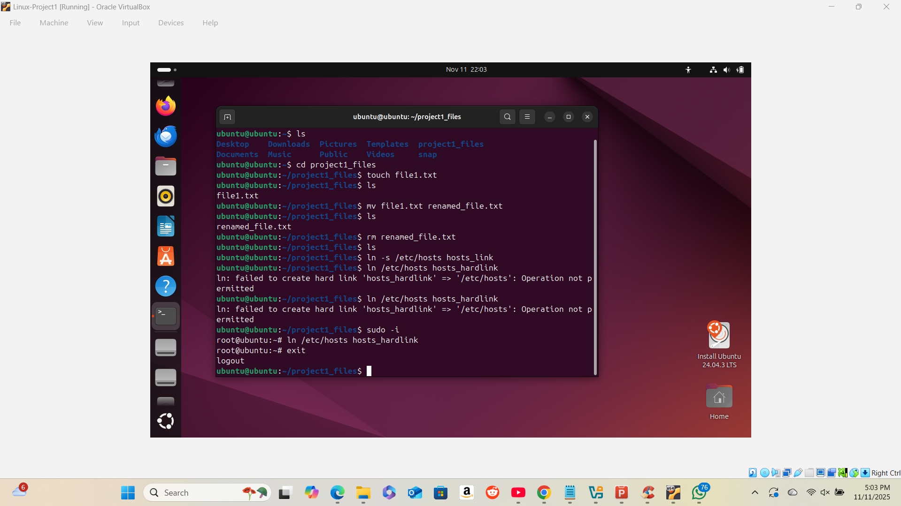

3.1 Create New Users and Groups
- Detail the commands used, their purpose, and any output observed.
sudo useradd student1 – Creates a new user named student1.
Output: No message if successful.
sudo passwd student1 – Sets a password for student1.
Output: Prompts to enter and confirm the new password.
sudo groupadd project1_group – Creates a new group named project1_group.
Output: No message if successful.
sudo usermod -aG project1_group student1 – Adds student1 to the project1_group group.
Output: No message if successful.

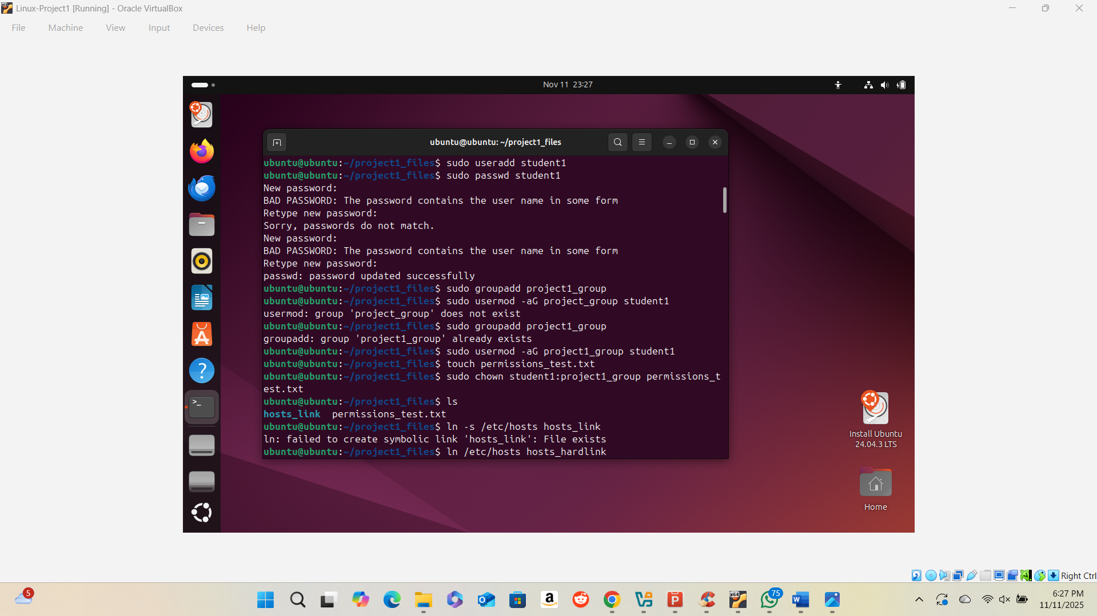
3.2 Modify File Permissions
- Explain what each permission command achieves.
chmod u+rw permissions_test.txt – Gives the file’s owner (user) permission to read and write the file.
chmod o-w permissions_test.txt – Removes the write permission from “others,” preventing them from editing the file.

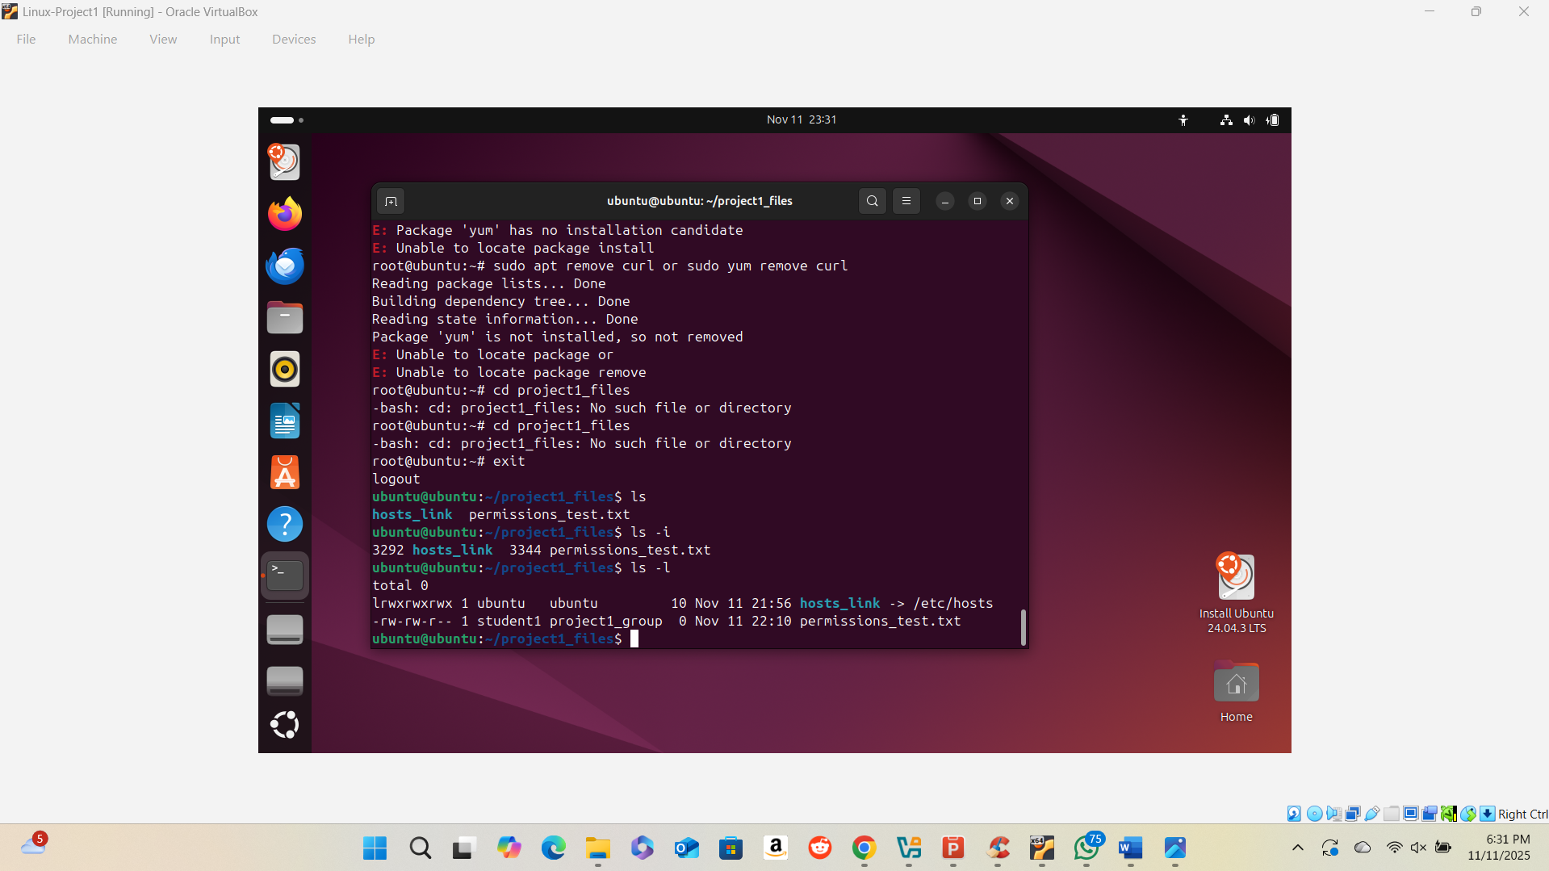

4. Part 4: Package Management
4.1 Install a Package
- List the commands with explanations and expected outcomes.
sudo apt update – Updates the list of available software packages (keeps the system up to date).
sudo apt install curl – Installs the curl package, a tool used to transfer data from or to a server.
curl --version – Verifies the installation by displaying the installed version of curl.

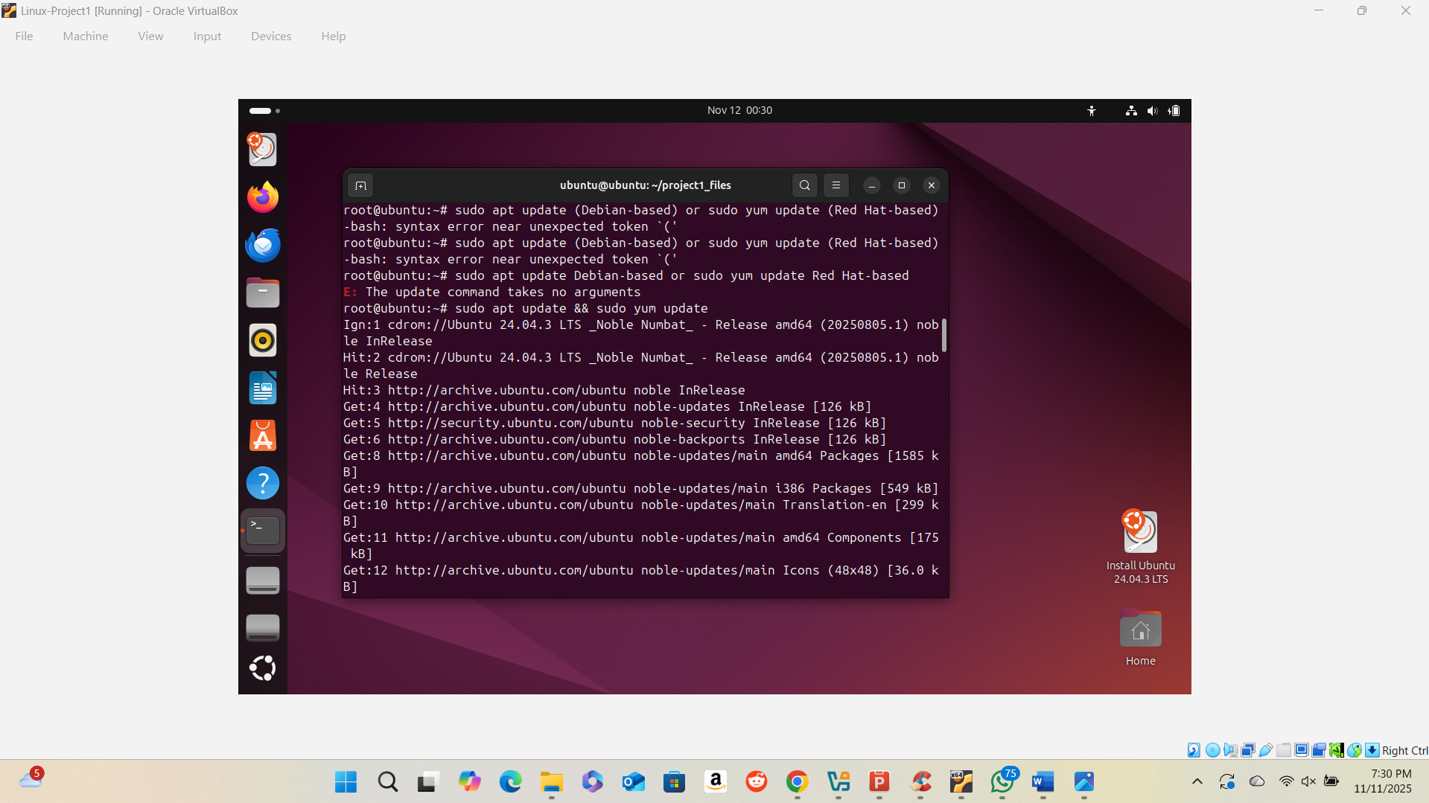

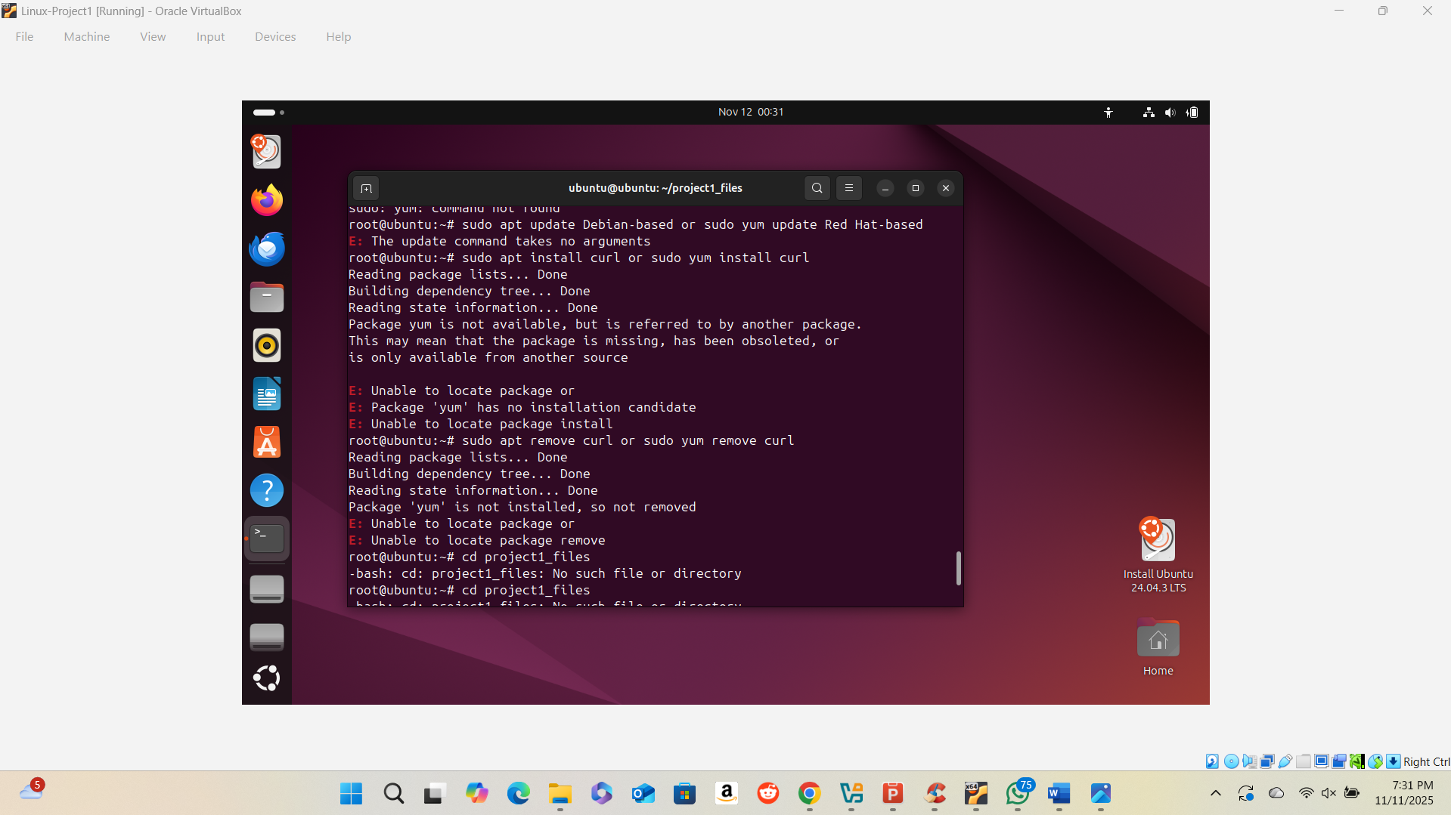

4.2 Uninstall a Package
- Describe the removal process and verify with a screenshot.
sudo apt remove curl – Uninstalls the curl package from the system.

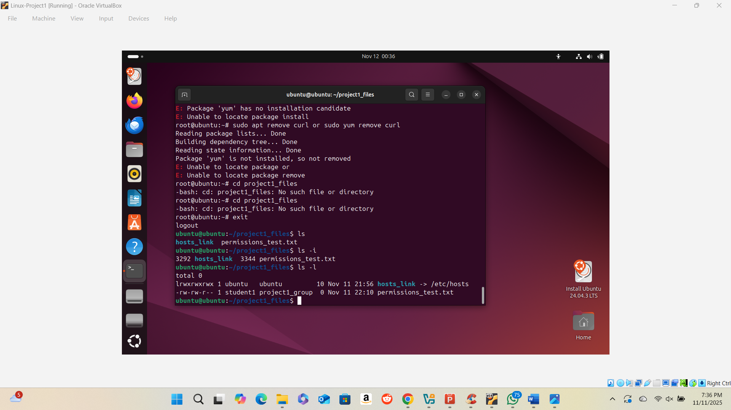

5. Conclusion
Provide a summary of your experience completing the project. Include reflections on:
1. What I Learned:
I learned how to install and use Linux through VirtualBox, manage files and users, and use terminal commands confidently.
2. Challenges Encountered:
I faced setup and boot errors during installation, but I fixed them by restarting, recreating the virtual machine, and carefully following each step.
3. Future Considerations:
I plan to keep practicing Linux commands, explore system administration tasks, and strengthen my skills in managing and securing systems.

References
Ubuntu Documentation. (n.d.). Ubuntu tutorials and guides. Retrieved from https://ubuntu.com/tutorials
Oracle Corporation. (n.d.). VirtualBox User Manual. Retrieved from https://www.virtualbox.org/manual/UserManual.html

